Post Lab

director
did | name | bestRev

movie
mid | mname | Directed_by

Given the relational model above:
- Give the table creation statements with all constraints in place

use [postlab4]
create table director
(
did int not null,
name varchar (20) not null,
bestRev varchar (30),
constraint DIRPK primary key (did)
);

create table movie
(
mid int not null,
mname varchar (20) not null,
Directed_by int,
constraint MOVPK primary key (mid),
constraint MOVFK foreign key (Directed_by) references director (did)
);

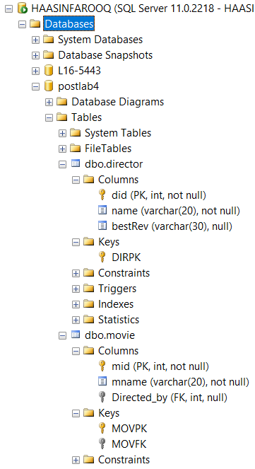
- Give the DDL statements to drop the primary key and foreign key constraints in real time

alter table movie drop constraint MOVFK
alter table movie drop constraint MOVPK
alter table director drop constraint DIRPK

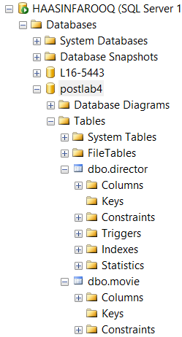

- Explore how you can set primary key constraints on the director table using GUI provided by SQL Server, include screen shots
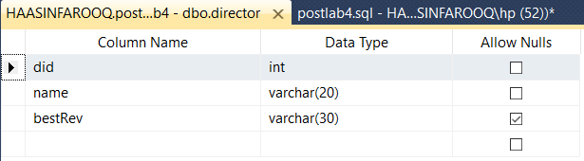

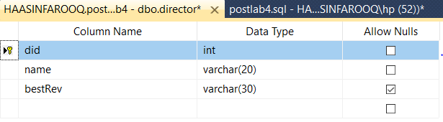

- Explore how you can set foreign key constraints between tables above by using the GUI provided by SQL Server, include screen shots

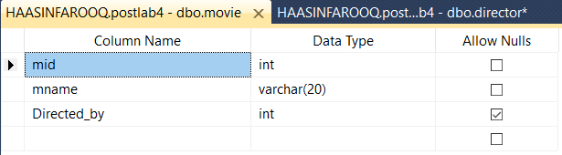

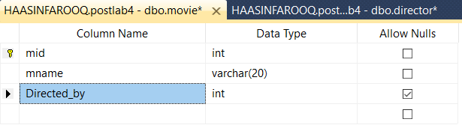

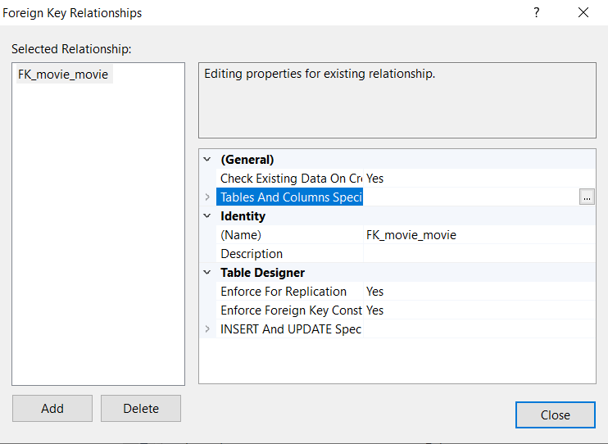

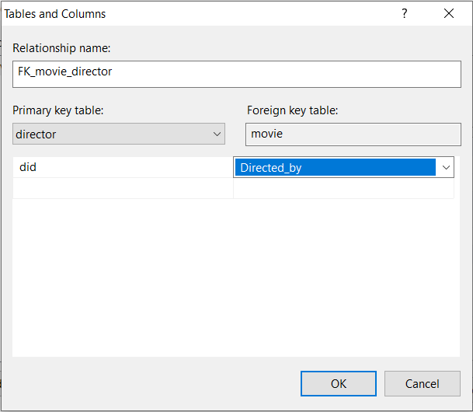

- Explore how Identity column works in SQL server, give the SQL DDL statement to add a column called Srno in movie table which would be an identity column

alter table movie add srno int identity(1,1)



- Give the command needed to make the srno column added above a unique key for the table.
Alter table movie add constraint MOVUK unique (srno)



- List the main differences between truncate and delete command

TRUNCATE | DELETE
DDL command | DML command
Removes all rows from the table | Removes rows based on WHERE condition
Uses less transaction space | Uses more transaction space
Faster | Slower
Executed using table lock where whole table is locked for removal | Executed using row lock where each row in the table is locked for removal

